SQL server architecture

I have to explain how to data flow from client to sqlserver client having client tool like odbc, oledb, net libraries, sql client. Server having server tools like db engine, storage engine, relation engine I/O manager. Suppose client send request server means it will pass through client to Sql native client to net libraries using TCP /IP connection packets are sending through TDS {table data stream} here TDS packets decrypted .It will send to relation engine to storage engine before sending check the syntax and parsing then relation engine check the execution plan, page located files then I will send to IO manger.
________________________________________________________________________

Single user mode server

How do I start SQL Server in single user mode?
From a command prompt (Start | Run | cmd) change to the directory where SQL Server is installed, and type the following:
sqlservr.exe -c –m
-----------------------
Minimal configuration Net start MSsqlserver \ -F
Single user mode Net start MSsqlserver \ -M
Dedicated admin Net start MSsqlserver \-E \-A

DBA should be
familiar with. -m is used for starting SQL Server in single user mode
and -f is used to start the SQL Server in minimal configuration mode.

Sql cmd –e

Select @@version
Go

Exit

Net stop MSsqlserver

Data base set in to single user mode

Alter database bank set single_user

Alter database bank set single_user with no wait

Alter database bank set single_user with rollback after 5min

alter database bank set single_user

alter database bank set emergency

alter database bank set multi_user

Database recover from suspectmode:
whenever database in suspectmode we need to run sp_reset status,next we need to put database in emergencymode,next run dbcc checkdb ,next database put in to single_user mode,next database recover to multiuser mode.

Configuration

Windows server 2003, with sp2 built number 4035

Sql server 2005 enterprise edition sp3, 32 GB RAM sql server 2008 sp2 latest service pack July 2010 released ,2000 sp4

Clustering system 200GB hard disk, Zenon processor 3.14,Net framework. Sql native client, Sql server setup support files

____________________________________________________________

Switches

AWE:
32 bit sqlserver not recognized more than 4 GB ram when ever we are enable this awe option then 32- bit sqlserver recognized then RAM .server properties memory then is option

Boot.ini we can change awe.pae options
sp_configure 'awe enabled', 1
go
sp_configure 'max server memory', 3584 -- for 3.5 GB
go
sp_configure 'min server memory', 1024 -- for 1 GB
go

Next do another reboot.

When SQL next starts you can check the configuration options with sp_configure.

PAE : 32 bit OS not recognized more than 4 GB ram when ever we are enable this option then 32- bit OS identified the RAM
Creating database

Create database bank
On
(
Name =bank,
Filename = d:\bank.mdf,
Size = 5mb,
Mix size= 20 mb,
Auto growth= 1mb
)

Log on
On
(
Name =bank,
Filename = d:\bank.ldf,
Size = 5mb,
Mix size= 20 mb,
Auto growth= 1mb
)

C:\Program Files\Microsoft SQL Server\MSSQL10.MSSQLSERVER\MSSQL\DATA
_____________________________________________________________________

Constraints
Not null
Check
Default
Primary key
Foreign key
________________________________
Alter table customer
Add constraint pk_id primary key (id)

Alter table customer
Alter column cust id int not null
________________________________________________________________________
In place upgradation

- Run upgrade advisor
- Log in as the Sql Service Account
- Make sure you set the AUTO_UPDATE_STATISTICS configuration option to ON before you upgrade any databases to SQL Server 2005.
- exec sp_help_revlogin_2000_to_2005, sp_change_users_login
- Backup all the databases
- Stop/Down the All SQL services.
- Copy data(mdf) & Log(ldf) from locations
- Run setup.exe and follow prompts to install fresh sql 2005 .
- Install sql 2005 sp2, Install Hot fix, Reboot the server
- SET compatibility level of 90 for all databases

SELECT name, cmptlevel
FROM master.dbo.sysdatabases

Run sp_Recompile all tables on each users database. (On each user database.)

Run update statistics on all users database

Side by side upgradation
- Jobs logins send source to destination using DTS
- Db_owner change 2000 to 2005 sp_change dbowner
- Compatible levels changing 80,90 sp_db _compatible level
- Collation setting , sp_helpsort
- Orphan users fixing using sp_change_user_logins ‘report’

Backups

Full backup every Friday 6 pm
Differential backup everyday evening 5 pm
Transactional backup every 15 min

Backup commands

Full: Backup database bank
To disk =‘d:\bank.bak ’

Diff: Backup database bank
To disk =‘d:\bank.bak ’ differential

Tran: Backup log bank
To disk =‘d:\bank.trn ’

Tail-log : Backup log bank
To disk =‘d:\bank.trn ’ with no truncate

File and file group backup:

If u have your data spread across multiple files or file groups you can take a full or differential backup of files or file groups

Filegroup: Backup database bank
File=’bank_file’
To disk =‘d:\bank.bak ’

Filegroup: Backup database bank
File=’bank_file’
To disk =‘d:\bank.bak ’ with differential

Partial file group backup:
Partial filegroup backups are used to backup large database with one or more read only file groups.

Partial: Backup database bank
read_write_filegroups,filegroup=’readonly_filegroup’
To disk =‘d:\bank.bak ’
For differential backups just add with differential option.

Restoring backups

Full: Restore database bank
From disk =‘d:\bank.bak ’ with no recovery

Diff : Restore database bank
From disk =‘d:\bank.bak ’ with no recovery

Tran : Restore log bank
From disk =‘d:\bank.trn ’ with no recovery

T- log: Restore log bank
From disk =‘d:\bank.trn ’ with recovery
Recovery models

Simple recovery, full, bulk logged

In simple recovery model we can’t take transitional log backup, in simple recovery model transaction when committed transaction write log file to data file. Next clear transaction. It truncate after transaction log backup. It means db recovered only up to last successful full.

This model maintains a transaction to the full recovery model. The main diff is that transaction log is minimal during bulk logged operation to maximize db. In full recovery model capture the entire all transaction. Possible to up to point to time & up to mint. to maintain the all transaction log backup disk will be full then take backup. Before take one full backup then take transactional log backup. Then commit transaction move transaction log to data file

Recovery modes:
- Restore with recovery
- Restore with no recovery
- Restore with standby

Restore with recovery: once restore completed then user can perform operations in the database.
Restore with no recovery: once restore is completed users can’t perform any operation the database
Restore with standby: once restore is completed users can’t access the database it is in read only mode

Lock escalation: Converting low level lock to high level lock. i.e. page & row level to table level

Raid levels: Redundant array inexpensive disk, raid levels are 4 types
Raid 0, 1,5,10 raid levels are implemented operating system level or hardware level.

Data file raid level = 10
Log file raid level = 1

ACID properties

Transaction is nothing but a logical unit of work. Every transaction follows acid properties. Atomicity, Consistency, Isolation, Durability

Atomicity: if all the operation completed successful then only transaction completed if any operation failed transaction to be rollback

Consistency: it is nothing but a providing correct data to the transition; it can be implemented with locking mechanism

Isolation: if one transaction failed it will not effect the other transaction

Isolation levels are read committed, read uncommitted, repeatable read, serialization snapshot

Durability: durability generates the result of every committed transaction should be permanently saved in database

Default isolation level is read committed

Temp database full my approach

Make database in single user mode and shrink the tempdb using dbcc shrinkdb

Stop and start sql services, it a session level tempdb will be recreated every time the sql server started

We can’t take backup of temp db , because it is a session level

Errors 1101,1105

Log file is full my approach

After taking transaction log backup truncate the transactional log, we have this option available in option page at the backup database dialogue box

shrink log file using Dbcc shrinkfile(bank_log, 20 )

Auto growth increase ,To know log space dbcc sqlperf (log space)

If the transaction log was not truncated, and the database have only one data file, detach the database by using the sp_detach_db stored procedure, then attach only the data file by using the sp_attach_single_file_db stored procedure. The transaction log will be recreated automatically with the small size. This is the example to detach/attach the Test database

Normalization:
The process of applying normal forms sequent on the database design is called normalization
- No multi value columns
- No partials dependency, every non key column should depends on completely in primary key
- No transitive dependency , non key column not depend up on other non key column is call called transitive dependency

De normalization: Reverse process of normalization is call de normalization, reduce the data redundancy, transitive dependency partial dependency.

Server level permission:

- Sys admin
- bulk admin
- setup admin
- process admin
- db creator
- server admin
- disk admin

Database level permissions:
- db_owner
- db_accessadmin
- db_datareader
- db_datawriter
- db_securityadmin
- db_deny data reader
- db_deny data writer
- db_ddladmin
- db_backupoperator

Permission for restore database

Database level: db_owner, db_backup operator
Server level: db creator

DBCC Commands

- Dbcc sqlperf [logspace]
- dbcc update statistics
- dbcc reindex
- dbcc shrink database
- dbcc check db
- dbcc checkcatalog
- dbcc inputbuffer
- dbcc opentran
- dbcc outputbuffer
- dbcc show_ statistics
- dbcc show contig

Trouble shooting, query running very slow reasons

- No indexes then run dbcc update statistics
- Too much normalized tables
- locking ,isolation problems
- blockings
- missing date function
- stored procedure & triggers with out set no count
- poorly written query unnecessary compiled with joins

Then some of the tools help to trouble shoot these issues
Estimated plan,actual plans checking :

Estimated execution plan

- Set showplan_xml on
- Set showplan_all on
- Set showplan_text on
- Using ssms
- Using T-Sql commands

Actual execution plan

- Set statistics xml on
- Set statistics profiler
- Using ssms
- Using T-Sql commands

Server is very slow then trouble shooting

- Very first i need to check process speed & memory utilization if process speed more than 80% then problem with processor. Memory utilization more than 40 to 45% then problem with memory using performance monitor we will find

- Activity monitor this tools display then info
Which process is running?
Locking, blocked process we will check using sp_who, sp_lock, sp_who2

- DMVS these views and function gives server state information that can be used to monitor health of the server instance sys.dm.tran_locks, sys.dm.db_missing_index_details, sys.dm_exec_query_stats,sys.dm_db_missing_index_group,sys.dm_exec_procedure_stats , sys.dm_exec_query_plan,sys.dm_exec_request

If any database of sql server is out of time it could slow down entire system. May be index is created using wrong column or users are required different data over time. This would require creating of new indexes. If any of these are true our database need to tuning. To do this one we need to use database tuning advisor before running tuning advisor we need to create workload you get this by running and saving a trace in profiler.
Profiler → Trace → Workload → Tuning

- Sql profiler ,all database engine events are tracked by this tool

Service account in sql server

- built-in system account
- domain user account

Authentication modes in sql

- windows authentication
- sql server authentication[mixed mode]

Rebuild system database in sql server

We need rebuild system database if the master database is corrupted or damaged

Step 1: Take a full backup of all a system and user database rebuilding the system we need to restore to avoid the data loss
Step 2: copy the sql 2005 setup file from cd to the hard disk. In the command prompt

Start/wait setup.exe/instance name=’MSSQLSERVER’ reinstall= sql engine rebuild database

Moving tempdb database & model & msdb

Use master
Go
Alter database tempdb modify file [name=temp,filename=’newpath’]
Go
Alter database tempdb modify file [name=templog,filename=’newpath’]
Go

Next restart services

Then check temp db location

Select physical_name from sys.database_files

Dead lock:

When two users have lock on separate objects and each users want a lock on the other object. 1205 error

High availability concepts

- Log shipping
- Replication
- Mirroring
- Clustering

Log shipping:

The process of copying the transaction log data from one server to another server
To implement the transaction log shipping 3 server required

- Primary server
- Secondary server
- Monitor server

Primary server which contain original db.

A server which contains a copy of original db, secondary server db recovery states no recovery or stand by

Monitor server doesn’t provide automatic failover, it is maintain backup information of primary server backup info, secondary restore info it is maintaining

Log shipping process: log shipping uses sql agent on the participating servers to execute the process that maintain a warm stand by server.

- Backup the transaction log on primary server. A sql agent job on the primary server backup the transaction at a user-configurable time interval to a file in a backup folder. The backup job default name is LSBACKUP_DATABASE and it execute an operating system command to backup the transaction log.

- Copy the transaction log to the stand by server. A sql agent job on the stand by server uses UNC or shared drive to access the backup folder on the primary server to copy the transaction log file to a local folder on the stand by server. Copy job default name is LSCOPY_SERVERNAME_DATABASE it execute an operating system command to copy the transaction log.
- Restore the transaction log on the stand by server. To restore the transaction log, the database must be in either stand by or no recovery mode. Default job name LSRESTORE_SERVERNAME_DATABASE
and it execute an operating system command to RESTORE the transaction log.

Most of the log shipping objects can be found in MSDB.

Deploying with T-SQL commands:
- primary server, executed the following stored procedure in MSDB

master.dbo.sp_add_log_shipping_primary_databse

master.dbo.sp_add schedule

msdb.db.sp_attach_schedule

msdb.dbo.sp_update_job

master.dbo.sp_add_log_shipping_alert_job

on the secondary server execute the following stored procedure.

master.dbo.sp_add_log_shipping_secondary_primary

master.dbo.sp_add schedule

msdb.db.sp_attach_schedule

msdb.dbo.sp_update_job

msdb.dbo.sp_update_job

backup on the primary server,execute this stored procedure in the MSDB.

Monitoring and trouble shooting:
Log shipping has monitoring capabilities to identify the progress of the backup, copy, restore jobs. If any one of the job failed you need to check SQL agent job history and windows event viewer identified the error message and correct it. Also monitor helps to determine if the backup, copy, restore jobs are out of sync with the standby server. There are two approaches to monitoring the log shipping process.

Using the transaction log shipping status report or execute report or execute master.dbo.sp_help_log_shipping_monitor stored procedure.
Either method can help you determine if any standby server is out of sync with the primary server and what is the time delta between the two. You can also determine which jobs are not making any progress and the last transaction log backup, copy and, restore file name processed on the stand by server. Another log shipping alerts job that check if a present thresh hold has been executed by executed the sys.sp_check_log_shipping_monitor_alert. Stored procedure.
We will get transactional log shipping status report from the monitor server. Server -> properties ->reports->transaction log status

 |  |  |  |  |  | 
 | Transaction Log Shipping Status
 | RAJESH-PC
 | This report shows the status of log shipping configurations for which this server instance is a primary, secondary, or monitor.
 |  |  |  |  |  |  | Backup |  |  |  | Copy | Restore
 | Status |  |  |  | Primary Database  -- Secondary Database |  | Time Since Last | Threshold |  | Alert Enabled | Time Since Last | Time Since Last |  |  | Latency of Last File |  | Threshold | Alert Enabled | Last Backup File | Last Copied File | Last Restored File
 | Alert |  |  |  | [RAJESH-PC].[bank] |  | 5476 min | 60 min |  | True |  |  |  |  |  |  |  |  | bank_20100816091801.trn
 |  |  |  |  | -- [RAJESH-PC\PUNE].[bank-2]

Planned fail over:

- Stop the primary server transactional log backup job.
- Manually copy all transactional log backups that have not been copied from primary server backup folder to the secondary server folder. Then restore each transaction log in sequence to secondary server. A different option is to execute the log shipping copy and restore jobs to restore the remainder of the transaction logs.
- Stop and disable the secondary server’s copy and restore jobs
- Execute the sync secondary server access information job then disable it.
- Backup the active transaction log from primary to the secondary server with NO RECOVERY

Unplanned
If the primary server is unavailable some data loss is probable. Ex: active transaction log may not be accessible or last transactional log backup may not reachable. We need to check last copy & restore transaction log have been restored by using log-shipping monitor.
Switching between primary & secondary roles

- Stopping and disable the primary server backup job
- Verifying that all the transaction log backups have been copied and restored, either manually or by executing the jobs to do that.
- Executing the sync logins job
- Stopping and disable the transactional log copy & restore jobs in secondary server.
- Backing up active transaction log on the primary server with no recovery.
- Restoring the active transaction log backup on the secondary server.
- Restoring secondary server’s database with recovery
- Executing the resolve logins job
- Enabling the transactional log backup job on the new primary server to log-shipping to the secondary server
- enabling the secondary server copy job & restore jobs
- enabling synchronization of the logins and database users

Deleting log shipping with T-sql commands:

Removing log shipping in primary server

use master

sp_delete_log_shipping_primary_secondary @primary_database,@secondary_server,@secondary database;

on secondary sever

use master

sp_delete_log_shipping_primay_database @database;

logshipping tables

- log_shipping_database
- log_shipping_monitor
- log_shipping_plan_database
- log_shipping_plan_history
- log_shipping_plans
- log_shipping_primaries
- log_shipping_secondaries

Replcation

Replication is nothing but the concept of auomatic migration of database objects from one server to another server. Replaction always maintain multipul copies of the same database on multiple servers. It is in crease the data availbulity. Improves perfmonce

- Publisher
- Distibuter
- Subscriber

Publisher contain original database and ariticals.publisher can be configured as self distributor also.

Distibutor is nothing but a intermediate bwteen publisher & subscriber

Active:
Once the data has been identified by publisher before data send to the subscriber it makes it has multiple copies. How many subscribers that much will take create copies.And before the data to be transferred to the respective subscribers No of subscribers +1 maintains storage

Passive:
In case of passive identified source –destination pick up data from source put it on to destination send message to publisher

Subscriber is nothing but a server which need articals from the publisher. Subscriber may be push or pull subscription

Types
- Snapshot replication
- Transactional replication
- Merge replication
- Transactional replication with updateable subscriber

Subscritions:
- push subscription
- pull subscription

Replication agents
- Snapshot agent
- Log reader agent
- Merge agent
- Queue reader agent
- Distributor agent
Snapshot agent:
The Replication Snapshot Agent is an executable file that prepares snapshot files containing schema and data of published tables and database objects, stores the files in the snapshot folder, and records synchronization jobs in the distribution database

Log reader agent:
The Replication Log Reader Agent is an executable that monitors the transaction log of each database configured for transactional replication and copies the transactions marked for replication from the transaction log into the distribution database

Distributor agent:
The Replication Distribution Agent is an executable that moves the snapshot (for snapshot replication and transactional replication) and the transactions held in the distribution database tables (for transactional replication) to the destination tables at the Subscribers

Queue Reader Agent:

The Replication Queue Reader Agent is an executable that reads messages stored in a Microsoft SQL Server queue or a Microsoft Message Queue and then applies those messages to the Publisher. Queue Reader Agent is used with snapshot and transactional publications that allow queued updating

Merge agent:

The Replication Merge Agent is an executable that applies the initial snapshot held in the database tables to the Subscribers. It also merges incremental data changes that occurred at the Publisher after the initial snapshot was created, and reconciles conflicts either according to the rules you configure or using a custom resolve you create

Snapshot replication: In this name itself says snapshot means generally a photo copy of data. A Xerox copy of data, blue print of the database

So at the movement when ever the replication starts what is the status of data in the data being select for replication. That photo copy is taken and directly sends to subscriber. And very next movement onward next transaction on wards any thing happens on replication data means the data being configured for replication. Suppose we start snapshot at 10 clocks exactly when system time matching to 10 whatever the status of the data will send subscribers, next transaction onward it will send to next schedule.

Example: I send from 1 pc to 10 pcs then they can do whatever they want like modify, delete, and change all types of modifications done by those pcs.
Now all modification not reflected on all the pcs at time.

Transactional Replication
What happens in case of transactional replication it is also first take snapshot on first of all one time. When ever the replication starts it takes the snapshot of data and to subscriber and next transaction onwards for which data being configured for replication .if any modification happens in the data will be send immediately to subscriber.

Merge replication:

In case of merge replication what will do is snapshot takes first send to subscriber. So the next moment onwards any modification done in source side data it keeps on monitor. Snapshot sends to subscriber after that next moment onwards a transaction by transaction it keep on files up the time. So once file up what it will do is over period of time means how long it will wait is there is a check point issued by OS once the check point issued what ever medication is there in source all data send to subscriber

- snapshot
- takes transaction by transaction
- once check point issue
- Send to subscriber

Transactional replication with updatable subscriber:
Data has been send to subscriber, any medication done by source that revert to subscriber if any medication done by subscriber that will not revert back to source these one all

ATM Centers it we take money from any ATM it will be updated.

Replication tables:

- MSdistribution_agents
- MSsnapshot_agents
- MSlogreader_agents
- MSmerge_agents
- MSlogreader_history
- MSsnapshot_history
- MSdistribution_history
- MSmerge_history

- MSarticles
- MSrepl_version
- MSrepl_transactions
- MSdistributor
- MSrepl_commands
- MSrepl_errors

Stored procedures:

- Sp_helppublication
- Sp_helpdistributor
- Sp_helpsubscription
- Sp_logreaderagent
- Sp_helparticals
- Sp_add articals
- Sp_addlogin
- Sp_addpublication
- Sp_adddistributor
- Sp_addpushsubscription
- Sp_pullsubscription
- Sp_repldone

DMVS:

- Sys.dm.replarticals
- Sys.dm.repltraninfo
- Sys.dm.repltranhash
- Sys.dm.replschemas

Replication jobs

- Replication agents checkup
- Replication monitoring refresher for distribution

Peer to Peer Replication:

Peer-to- peer is a type of transitional replication. It provides a headless topology, where there is no single publisher and one more subscriber. In peer to peer replication every participate is both a publisher and subscriber. It is suited for cases where user’s applications need to read or modify data at any of the database that participate in the setup. It is providing an interesting alternative for load-balancing and high-availability scenarios. Note this feature is only available in the enterprise edition SQL SERVER 2005. Oracle calls this kind of replication ‘multi master’, whereas DB2 calls it ‘update any where’.

- It’s designed for a small number of participating databases. A good rule of thumb number is less than 10. If you use more than that, you could encounter performance issues.
- Like merge replication, peer to peer replication does not handle conflict resolution.
- Peer to peer also does not support data filtering, That would defeat the purpose because every body is an equal partner here for high availability and load balancing
- Applications can scale out read operation across multiple databases. Databases are always online. Participating nodes can be added or removed
Create publication-> properties-> allow peer to peer replication -> true->configure peer to peer replication

Prerequisites for log shipping configuration

Database should be full or bulk recovery model, sql server edition, and same case sensitivity

Prerequisites for cluster configuration

For clustering configuration TCP/IP must be started on every node you plan to include cluster using the STRTCP , TCP loopback address must be configured and must show a status of active , using WRKTCPSTS WORK WITH TCP/IP NETWORK STATUS on every node in cluster. port 5550 and 5551 reserved for IBM clustering must not use for another application. Virtual ip address

Mirroring
New mirroring session to be established the partner and witness if any must be running on the same version , principal & mirror same edition standard later version supports , no recovery option

Failover

Alter database bank
Set partner failover

Alter database bank
Set partner force_ services _allow _ data _loss

Database Mirroring Concepts
Principal: The principal server is the primary database. This acts as a starting point in a database mirroring session. Every transaction that is applied to the principal database will be transferred to the mirrored database.
Mirror: Mirror is the database that will receive the copies from the principal server. There should be consistent connection between the mirrored and the principal server.
Standby Server: In the process of database mirroring, a standby server is maintained. This is not accessible to the users. In case of the principal server failing, the users can easily switch over.
Modes of Database Mirroring: Database Mirroring can work in two ways: Synchronous or Asynchronous
A) Synchronous mode: This is also called as high safety mode. In this mode, every transaction applied to the principal will also be committed on the mirror server. The transaction on the principal will be released only when it is also committed on the mirror. Once it receives an acknowledgement from the mirror server, the principal will notify the client that the statement has been completed.

The high safety mode protects the data by requiring the data to be synchronized between the principal and the mirror server.
- High safety mode without automatic failover:

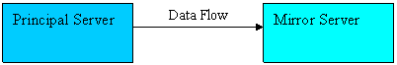
Transaction Safety set to full
When the partners are connected (Principal and Mirror) and the database is already synchronized, manual failover is supported. If the mirror server instance goes down, the principal server instance is unaffected and runs exposed (that is without mirroring the data). If the principal server is lost, the mirror is suspended, but service can be manually forced to the mirror server (with possible data loss).
- High Safety mode with automatic failover:
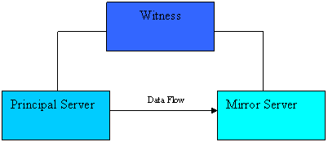
Transaction Safety set to full
Automatic failover provides high availability by ensuring that the database is still served after the loss of one server. Automatic failover requires that the session possess a third server instance, the witness, which ideally resides on a third computer. The above figure shows the configuration of a high-safety mode session that supports automatic failover.

B) Asynchronous mode: This is also known as the high performance mode. Here performance is achieved at the cost of availability. In this mode, the principal server sends log information to the mirror server, without waiting for an acknowledgement from the mirror server. Transactions on the principal server commit without waiting for the mirror server to commit to the log file. The following figure shows the configuration of a session using high-performance mode.
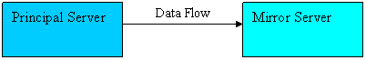
Transaction Safety set to off

This mode allows the principal server to run with minimum transactional latency and does not allow the user to use automatic failover. Forced service is one of the possible responses to the failure of the principal server. It uses the mirror server as a warm standby server. Because data loss is possible, one should consider other alternatives before forcing service to the mirror.
Preparing for mirroring:
To prepare for database mirroring, user has to perform three configuration steps:
1. Configuring Security and communication between instances: To establish a database mirror connection’s Server uses endpoints to specify the connection between servers. SQL Server performs authentication over the endpoints. This can be achieved by using Windows authentication or certificate based authentication. If witness server is also in the picture, then we need to specify the communication and authentication between the principal and the witness and between the mirror and witness. Here, since we will be creating the end point for database mirroring; only TCP can be used as transport protocol. Each database mirroring endpoint listens on a unique TCP port number.

Please Follow the screen shots to setup Database mirroring.
- Right Click on Database <AGTest> Go to Properties- Click on Mirroring.

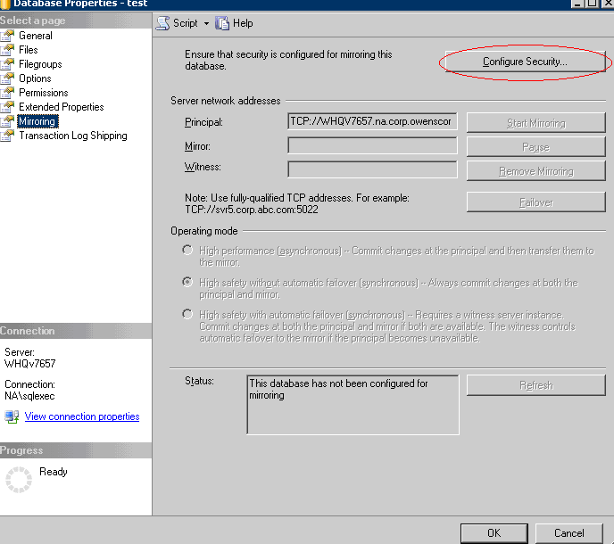
- Click on Configure Security button.

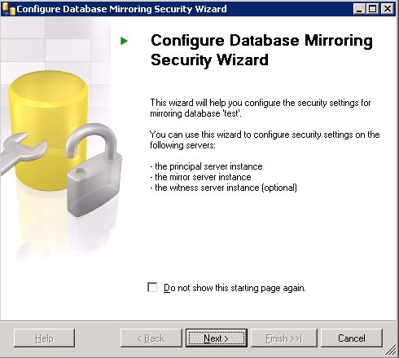
- Click on Next Button
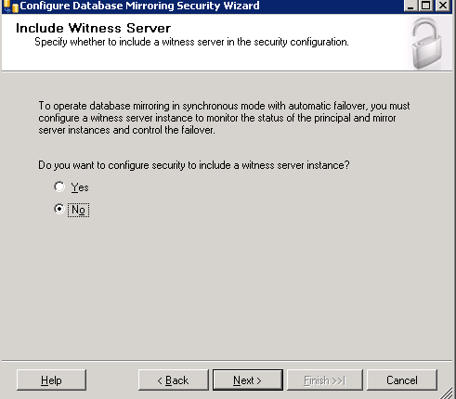
Note: If you want to configure Witness server Click on Yes radio Button if not Click No button. We are configuring without Witness box.
- Choose the server’s to configure (Principal & Mirror) Click on Next Button
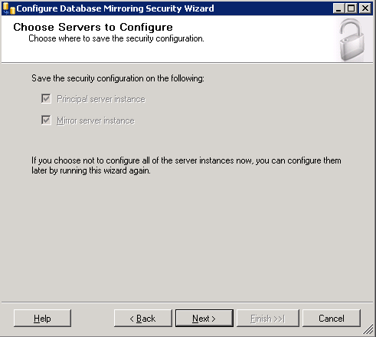

5. Set your Principal Server with Default settings.
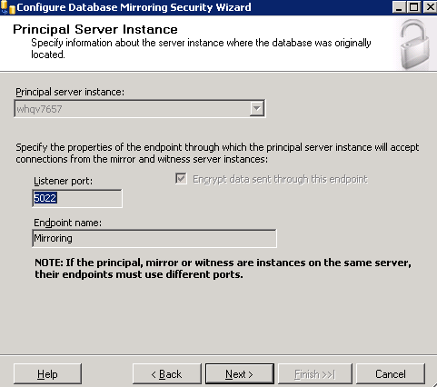
- Click on Next to Select Mirror Server Instance by using Pull down Menu and hit Connect Button
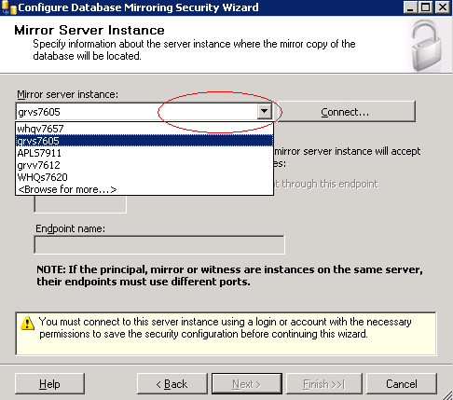
6. Verify Server name and Authentication and hit Connect
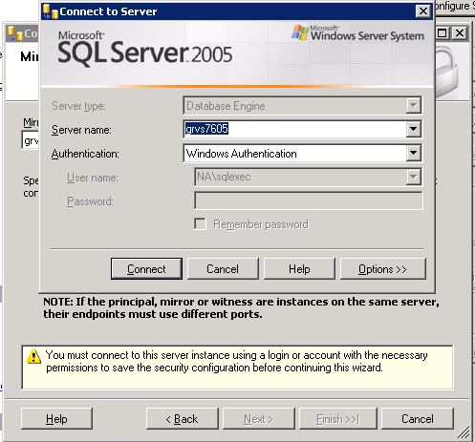
- Verify the listener port of Mirror server and hit Next.

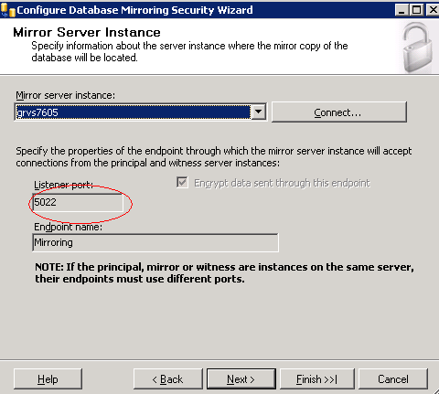
8. Service Accounts Screen Leave Both Principal and Mirror Fields Blank
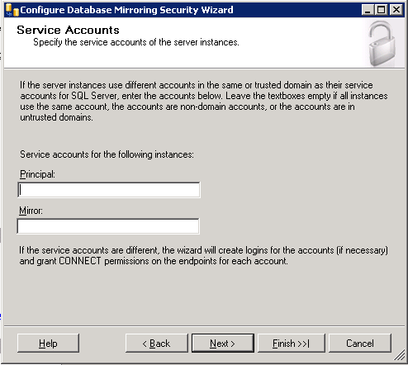
Verify the configuration before you hit finish Button

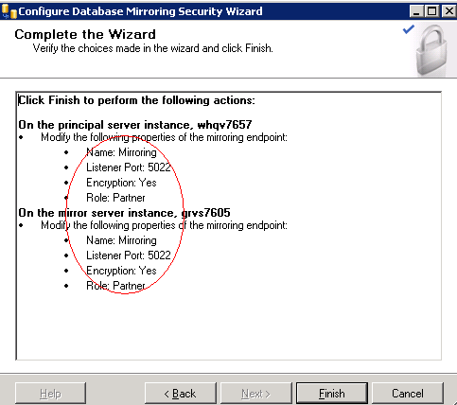
Once you hit Finish Button then you will get the below screen
10. Click on Start Mirroring Button
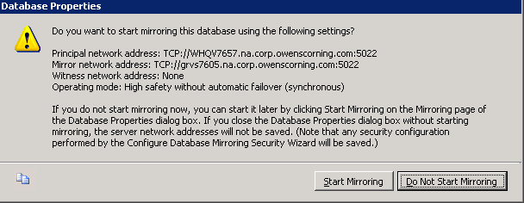

Specifies the TCP/IP authentication requirements for connections for this endpoint. The default is WINDOWS

Switching Roles
When the principal server fails, we have to switch roles over to the mirror and from then on specify that the mirror should become the principal database. This concept is called role switching. The three options for role switching are:
1. Automatic failover: - When the witness server is present in the database mirroring session, automatic failover will occur when the principal database becomes unavailable and
when the witness server confirms this. During the automatic failover, the mirror will be automatically promoted to principal, and whenever the principal comes back on, it will automatically take the role of mirror.
2. Manual Failover: - The user can perform manual failover only if both the principal and mirror are alive and in synchronized status. DBAs use this operation most frequently to perform maintenance tasks on the principal. The failover is initiated from the principal and later the roles are reverted after the database maintenance job is done.
The statement used to switch database roles (manual failover) is shown below:
ALTER DATABASE Adventure Works SET PARTNER FAILOVER
3.Forced Service :- When the witness server is not used and if the principal database goes down unexpectedly, then the user has to initiate manual failover to the mirror. In asynchronous mode of operation, user does not have any idea whether the transaction that have got committed on the principal have made it to the mirror or not. In this scenario, when the user wants to switch roles, there is possibility of losing data.
To achieve this, we need to invoke an ALTER DATABASE statement as shown below:
ALTER DATABASE Adventure Works SET PARTNER FORCE_SERVICE_ALLOW_DATA_LOSS.

